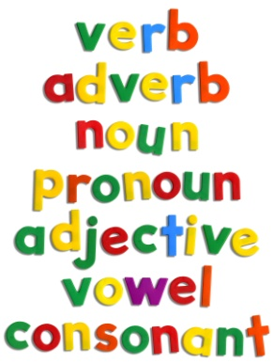
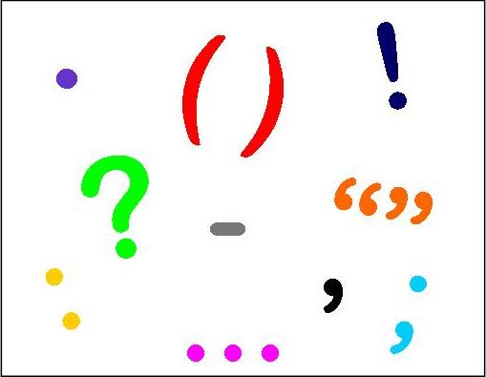

Grammar, Spelling and Punctuation Games KS1
http://www.topmarks.co.uk/Interactive.aspx?cat=42
http://www.bbc.co.uk/bitesize/ks1/literacy/
http://resources.woodlands-junior.kent.sch.uk/interactive/literacy.html
http://www.bbc.co.uk/bitesize/ks1/literacy/using_punctuation/play/
http://wickford-infants.iscoming.co.uk/wp-content/uploads/2012/03/Punctuation-fling-the-teacher.swf

Grammar and Punctuation Games KS2
http://www.topmarks.co.uk/english-games/7-11-years/spelling-and-grammar
http://resources.woodlands-junior.kent.sch.uk/interactive/literacy2.htm
http://www.bbc.co.uk/bitesize/ks2/english/spelling_grammar/
http://www.funenglishgames.com/grammargames.html
http://www.topmarks.co.uk/english-games/7-11-years/punctuation
http://www.everyschool.co.uk/english-key-stage-2-punctuation.html
http://www.crickweb.co.uk/ks2literacy.html
http://www.childrensuniversity.manchester.ac.uk/media/services/thechildrensuniversityofmanchester/flash/adjective_detective_stamp.swf
http://www.scootle.edu.au/ec/viewing/L8469/index.html

