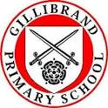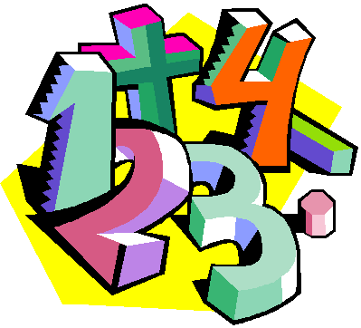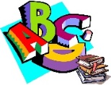

**Expressive Arts and Design**

Children will express their ideas through role-play activities including our class space rocket and farm shop. They will experiment with a range of media including paint, marbelling, printing, pencil and clay.

**Personal, Social and Emotional Development**

Children will:

* Become aware of behavioural expectations in school.
* Initiate conversations and take account of what others say.
* Understand that their actions can affect others.

**Understanding the World**

We will being by introducing the book of ‘Here We Are’ then explore the themes ‘Our Planet’, ‘Ourselves’ and ‘Our place in the world’.

In October our theme will focus on fruit and vegetables, harvest and Autumn. Children will observe plants in the environment and think about the changes in the season and the needs of a plant.

**Technology**

Children will use iPads and computers to develop their maths and literacy skills. They will take photographs using the iPads.

Autumn 1

**Important Dates for Reception**

Reading at Home Video released:

Thursday 1st October 2020

Please keep an eye on the school website for any forthcoming dates and follow your child’s learning on twitter as well as our class blog:

<https://gillibrandblogs.net>

@GPSOak

Reception

Curriculum Overview

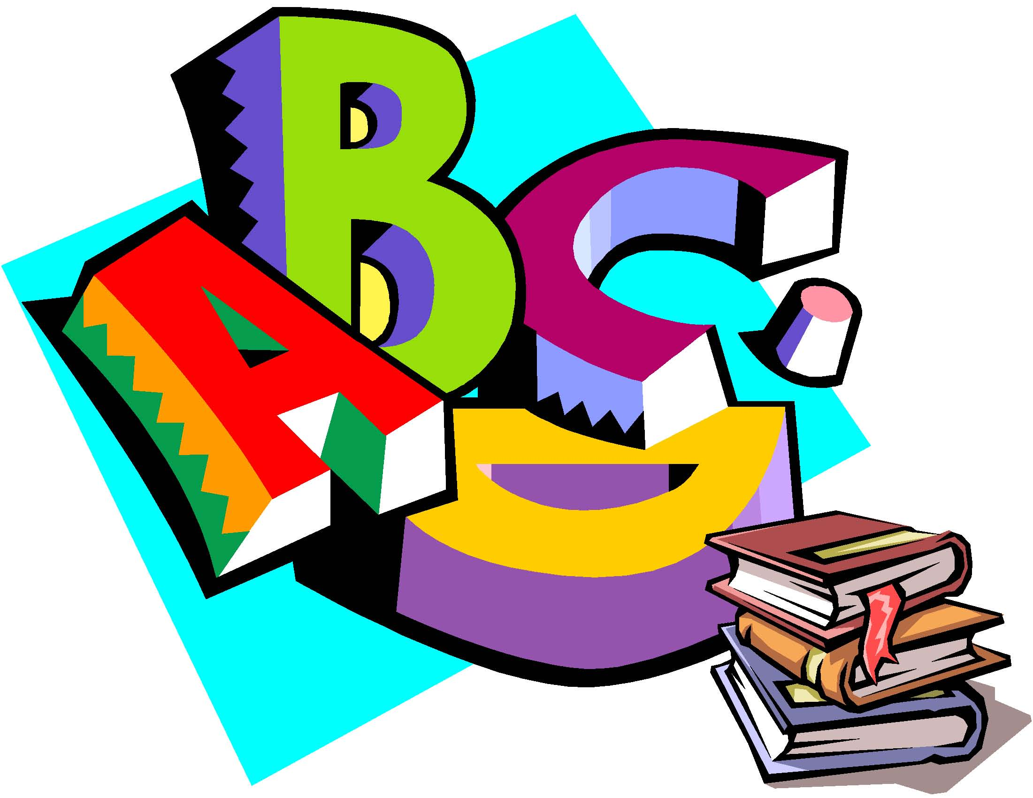

**Communication and Language**

Children will:

* Listen with increasing attention to stories and recall parts of stories.
* Join in with repeated refrains and anticipate key events.
* Ask and answer ‘who, what, when and why’ questions.
* Listen and respond to ideas expressed by others.

**Physical Development**

In PE lessons children will experiment with different ways of moving. They will learn how to use the space safely and experiment with different apparatus including balls and hoops.

Children will develop their fine motor skills by using malleable materials and simple tools like scissors. They will develop mark making skills using a variety of different techniques.

In addition, they will be encouraged to communicate their needs to others whilst develop skills in self-care. Children will also learn about ways to keep safe and healthy at skills.

**Literacy**  
This half term children will listen to and

join in with stories and poems. They will

learn how to handle books. Children will explore games and activities to enable them to hear, say and start to recognise initial sounds in words. Children will practise writing their own names.

**Mathematics**

The children will be learning to:

* Recite numbers in order to at least 10.
* Count amounts accurately, including numbers to 10.
* Recognise numerals to 10.
* Explore names and properties of 2-d shapes, recognising them in the environment
* Select named shapes to create and re-create patterns.

**Music:**

Children will explore percussion instruments whilst describing and experiment with creating sounds. They will learn songs and rhymes based on our themes and topic of study.